**Visually Expressing Thoughts using EEG-based system**

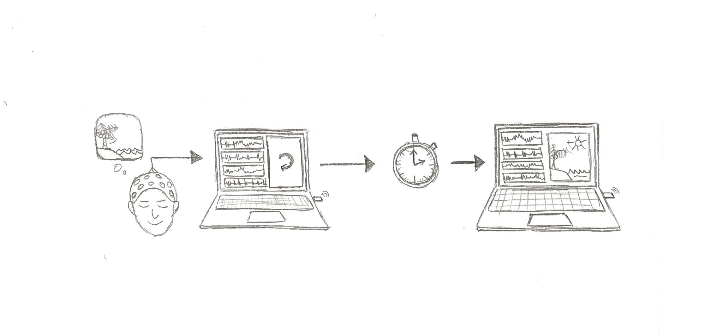

**Problem Statement**

In mental therapy, it can be difficult to explain our individual thoughts and feelings. This can make it difficult for professionals to understand how to provide the ideal care for their patients.

**Our Solution:**

With recent advances in large language models and generative AI, it has become easier to create visuals to convey ideas, places, or people.

We propose an EEG-based system that will process EEG signals to use as prompts for generative AI art models to build visuals of individual thoughts.

**Target Users**

Our target users are people who struggle with mental health problems and would benefit from being able to create visual representations of their thoughts to convey how they feel. We see this type of device being bought by professional mental health therapists to better understand their patients. This type of device would also help artists capture their imaginations and speed up their artistic processes.

**Potential Impact**

We believe that this type of device would help people get a glimpse into each other’s emotional and mental states. These visual representations could help people understand themselves better and open dialogue about how they feel.

**Questions & Concerns**

* What would be some potential spatial resolution problems for working with 16-channel EEG that we are constrained to for this class?
* A preliminary literature review has shown us that there are image reconstruction models that aim to produce semantically-similar visuals. Is it within scope to use EEG to identify emotional states and incorporate this in the generation of these visuals?